KNOW HOW TO
Shelter-In-Place
In the event of a chemical release, safety sirens near the facility in Contra Costa County’s industrial corridor will sound to alert the public while simultaneously sending CWS Emergency Alerts to you if you are in immediate area impacted. If you hear the sirens, or are told by emergency authorities to shelter-in-place, take these actions:
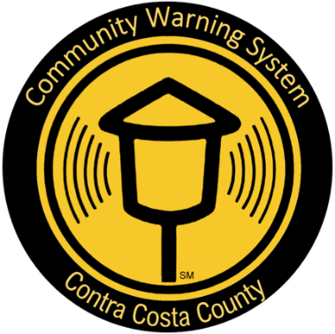

- Go inside (take pets with you)
- Close and lock all windows and doors (locking provides a tighter seal)
- Turn off all ventilation systems such as heating or air conditioning
- Close all fireplace dampers.
- If there are gaps in windows or doors, seal with tape or damp towels.
- Tune to KCBS 740 AM on the radio for additional instructions.

How long will the sirens sound? Sirens will sound initially for three minutes. They will continue to be re-sounded every 30 minutes if the event continues. Shelter-in-Place alerts are broadcast over weather radios in Contra Costa County, an alert to Shelter-in-Place is also sent out to affected areas located immediately surrounding event. You may receive a phone call to your land line and or cell phone, a wireless emergency alert (sounds like amber alert on your cell), a text message, or email prompting you to Shelter-to-Place immediately for your safety.

What should businesses do during a shelter-in-place event? Shelter employees and customers in place using the same steps as for a home. Close doors and windows, shut down heating and air conditioning systems, seal gaps and do not call 9-1-1 unless there is a life threatening emergency.

Where can people get information in languages other than English when the sirens sound?
The Community Warning System does have google translate on their website. You can also utilize your smart phone features as well. Phones may have more enhanced language translation capabilities. To sign up to receive emergency alerts go to www.CWSAlerts.com and to check translation features.

How will I know when the event is over? County authorities will announce the “All Clear” via news media. CAER recommends tuning to KCBS 740 on an AM radio. The safety sirens will NOT be sounded for All Clear.

Are the sirens tested? The sirens are tested on the first Wednesday of each month at 11:00 a.m. Instead of three minutes, they are sounded for only about one minute during the test. If you hear the safety sirens at any other time, you should shelter-in-place.


CCC CAER Group, Inc.
www.cococaer.org
Community Awareness Emergency Response
Agencies·Communities·Industries
“Working to Actively Enhance Public Health & Safety”
Wally Wise Guy
“Shelter, Shut & Listen”

For more information, call (925) 313-9296

